In First Question, The Data Created By the distribution is:

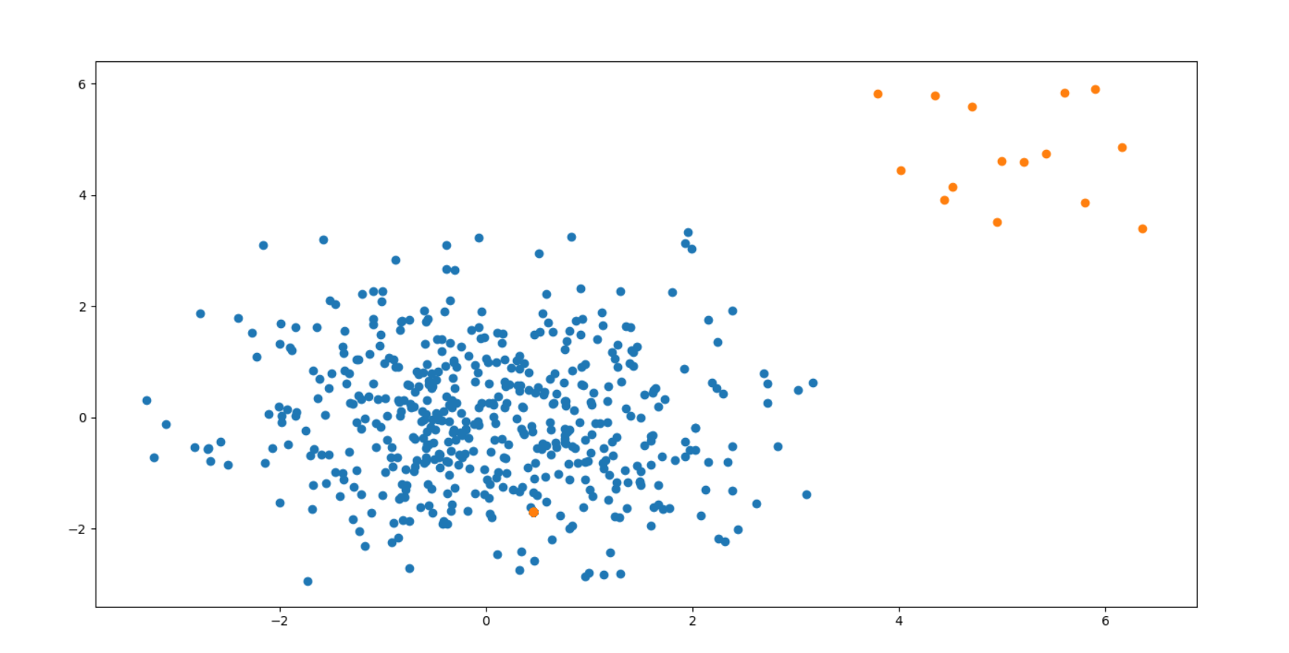

Which after using Kmeans with K=2 and clustering the results would be the following figure:

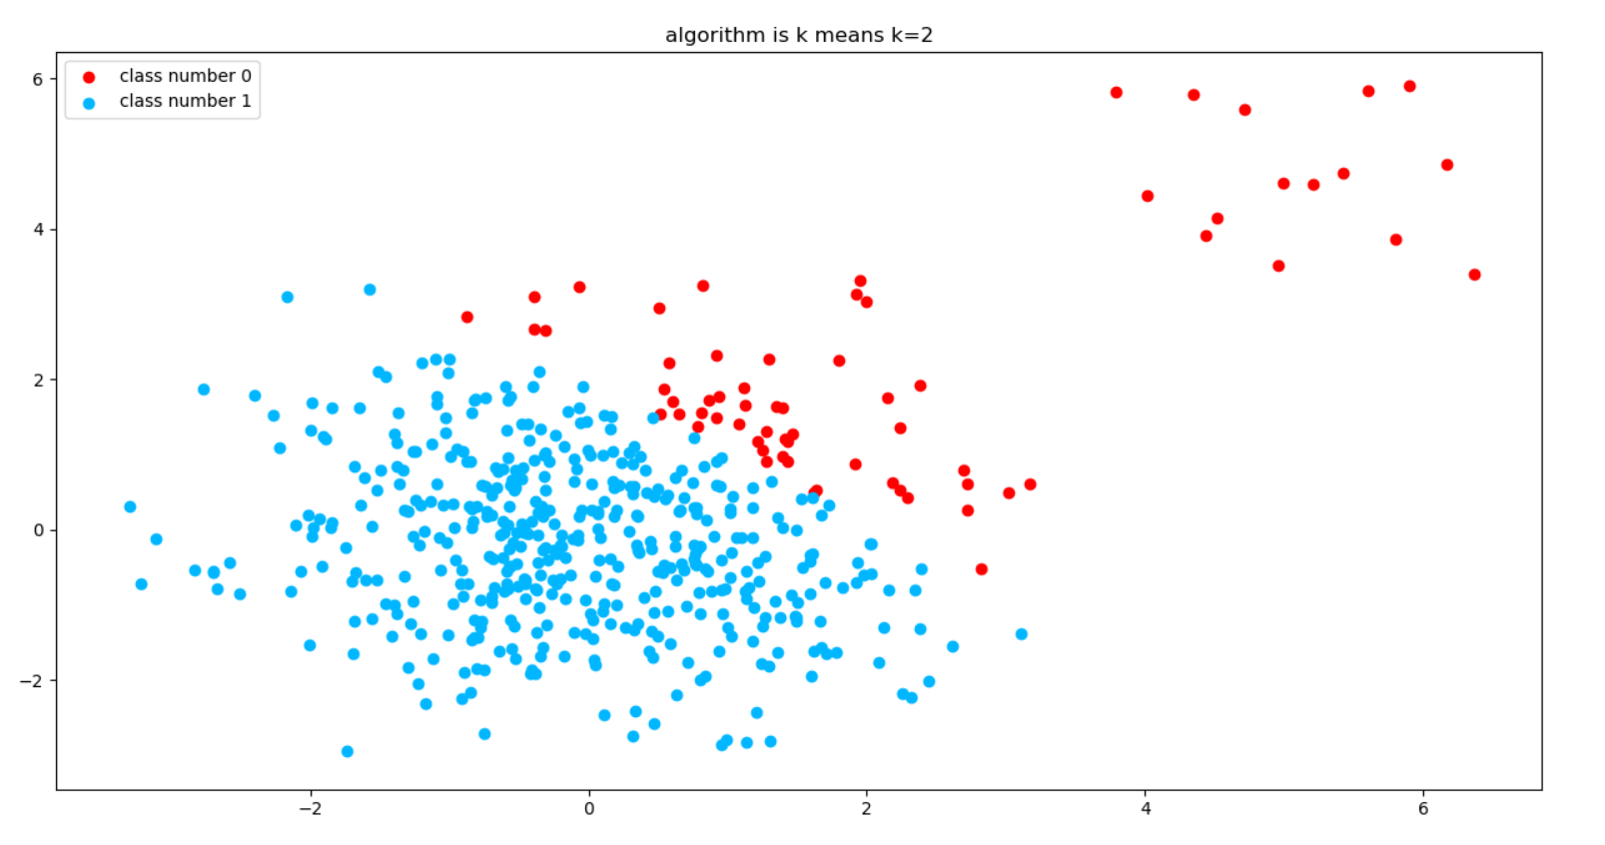

With Metrics of:

homogeneity score: 0.47

completeness score: 0.16

jaccard score: 0.10

normalized mutual information score: 0.28

silhouette score: 0.45

For example homogeneity that shows 47% of the data is in a same class when we clustered them.

For Second question data will be represented as follow:

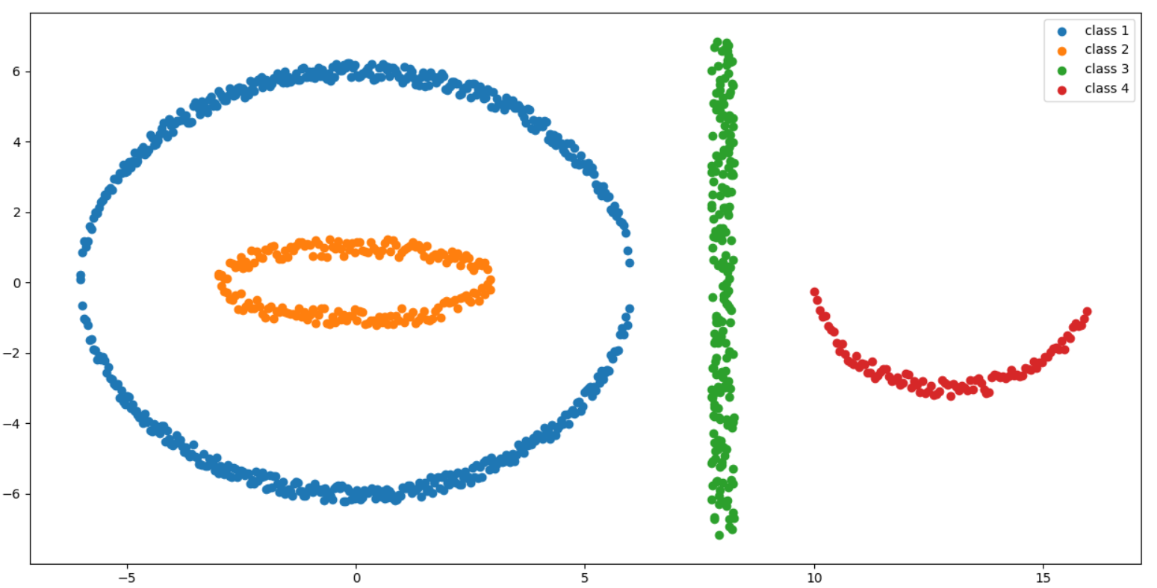

Which after clustering using Kmeans we reach to this figure:

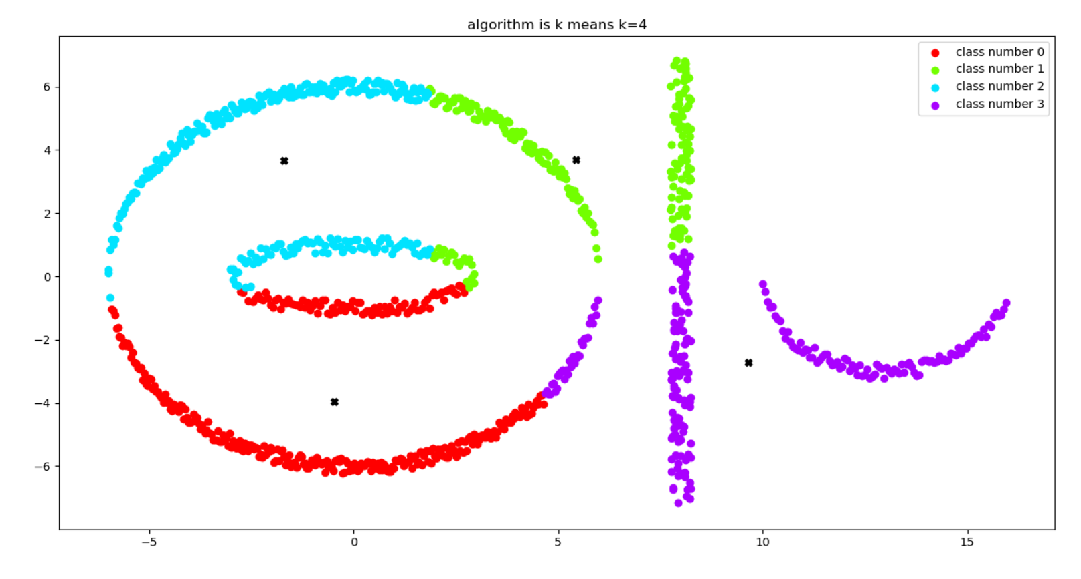which is expected because data is not compact enough and it’s fairly sparse. The measurements of this clustering will be as follows:

homogeneity score: 0.36

completeness score: 0.31

jaccard score: 0.28

normalized mutual information score: 0.33

silhouette score: 0.41

which also shows that.